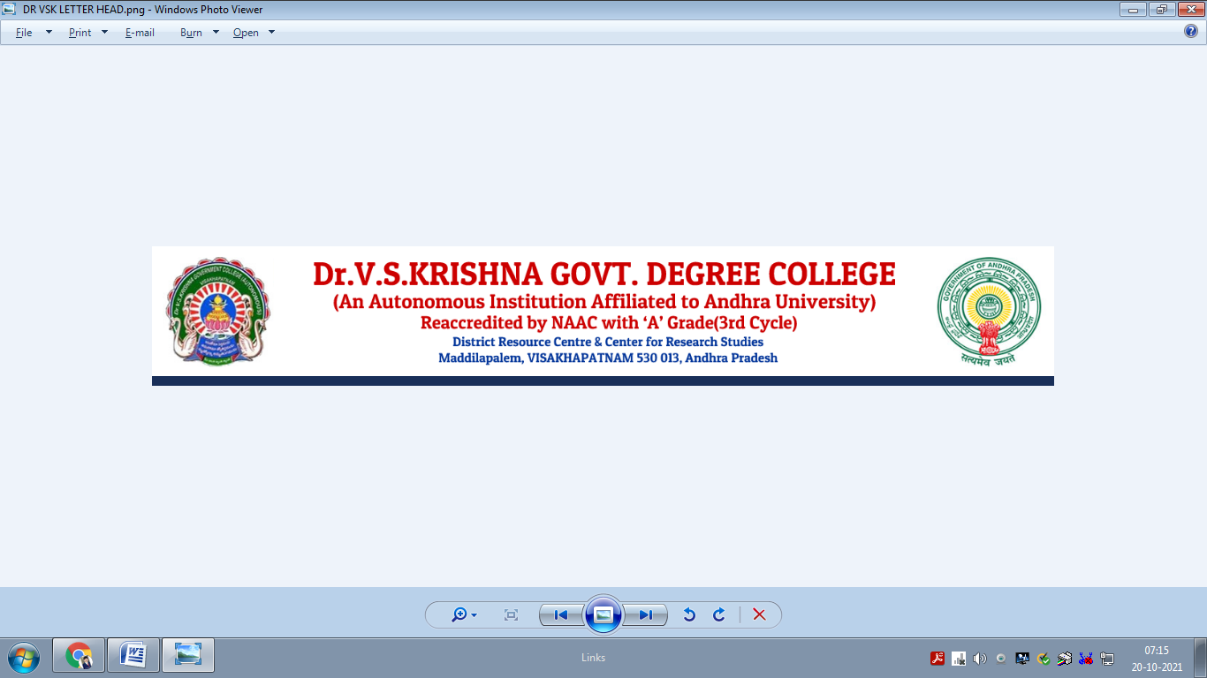

ACHIEVEMENTS
DEPARTMENT PHYSICS
2022 - 2023
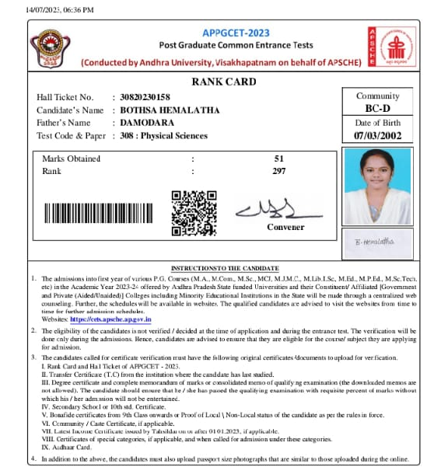
APPGCET – 2023

Name: Bothsa Hemalatha
Group Studied: B.Sc. (Physics-Honors)
Exam: APPGCET – 2023
Rank: 297

APPGCET – 2023
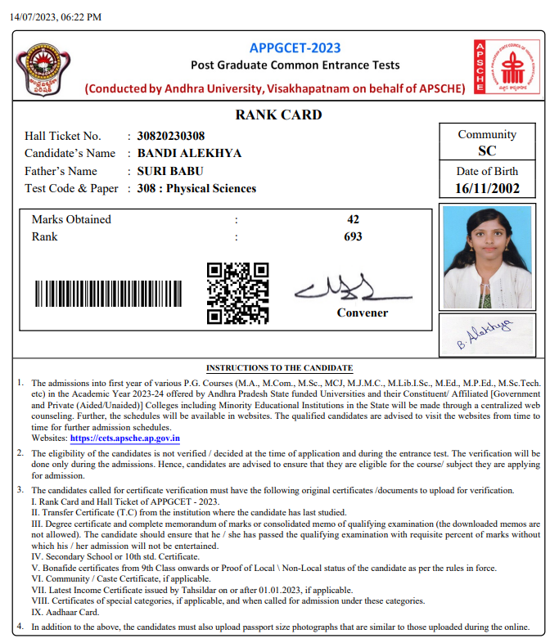

Name: Bandi Alekhya
Group Studied: B.Sc. (Physics-Honors)
Exam: APPGCET – 2023
Rank: 693

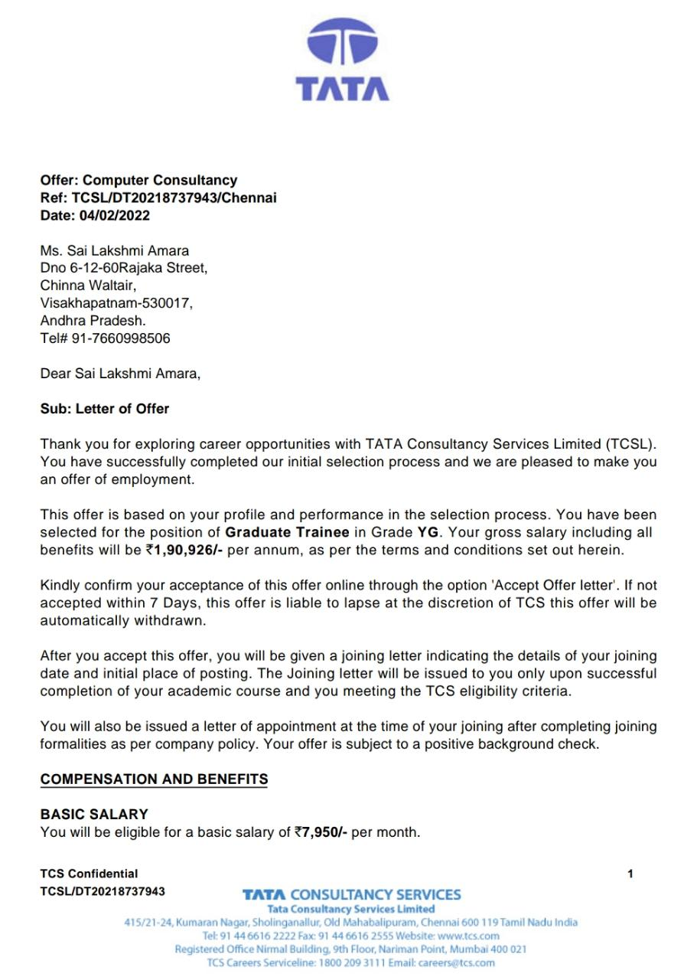
TCS NQT – 2022
JAM 2022 (IIT Roorkee)
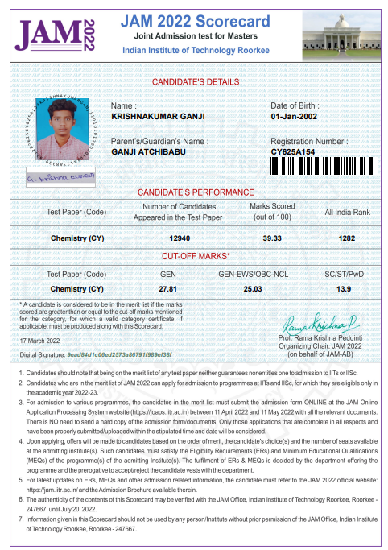

Name: Ganji Krishnakumar
Group Studied: B.Sc. (MPC)
Exam: JAM (IIT) – 2022
Rank: 1282
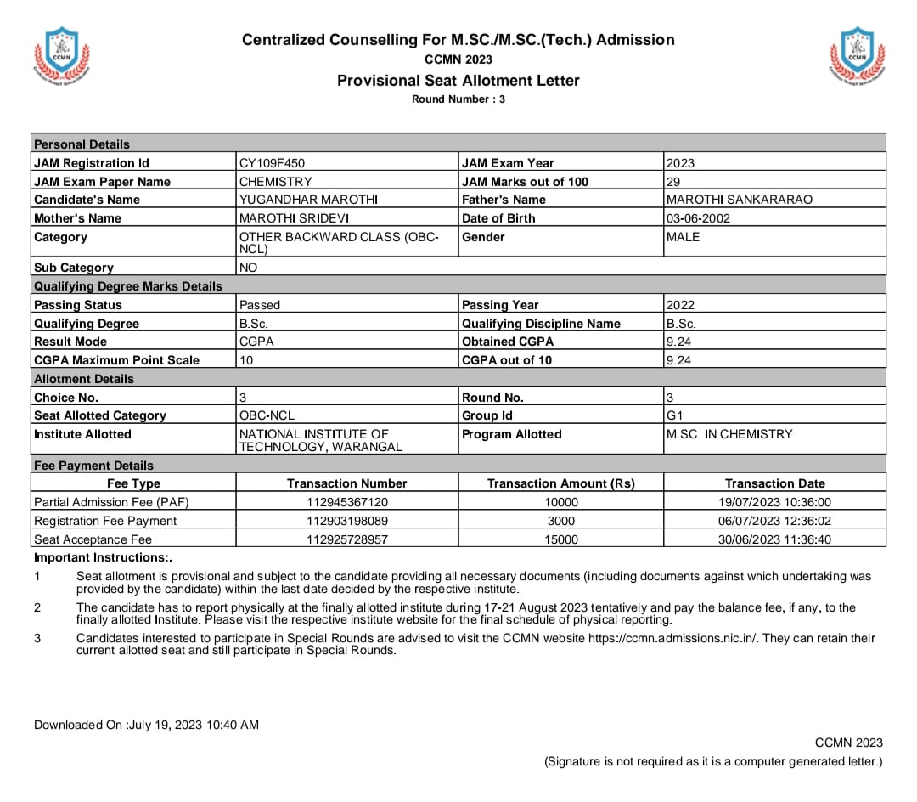
JAM 2023 (IIT Guwahati)

Name: Marothi Yugandhar
Group Studied: B.Sc. (MPC)
Exam: JAM (IIT) – 2023
Rank:
Marks scored: 29 (Out of 100)

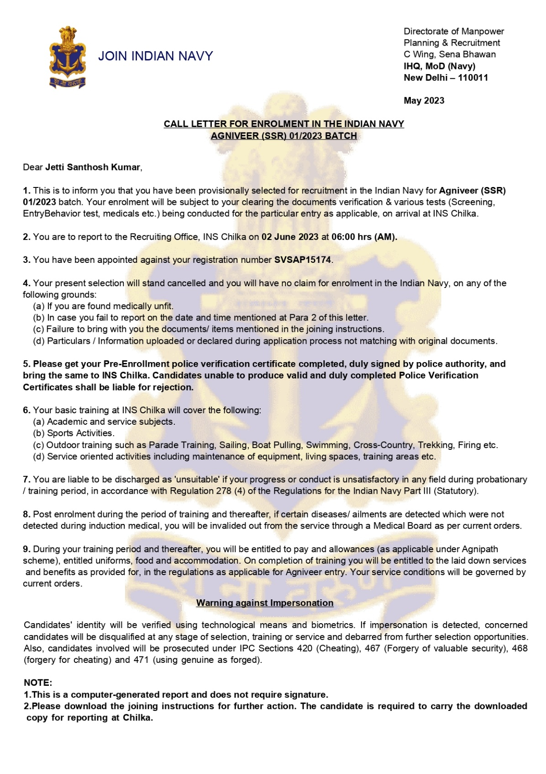
Indian Navy (Agniveer) recruitment 2023

Name: Jetti Santosh Kumar
Group Studied: B.Sc. (Physics-Honors)
Exam: Indian Navy
Rank: Agniveer (SSR)
Marks scored: Selected for the recruitment in the Indian Navy

