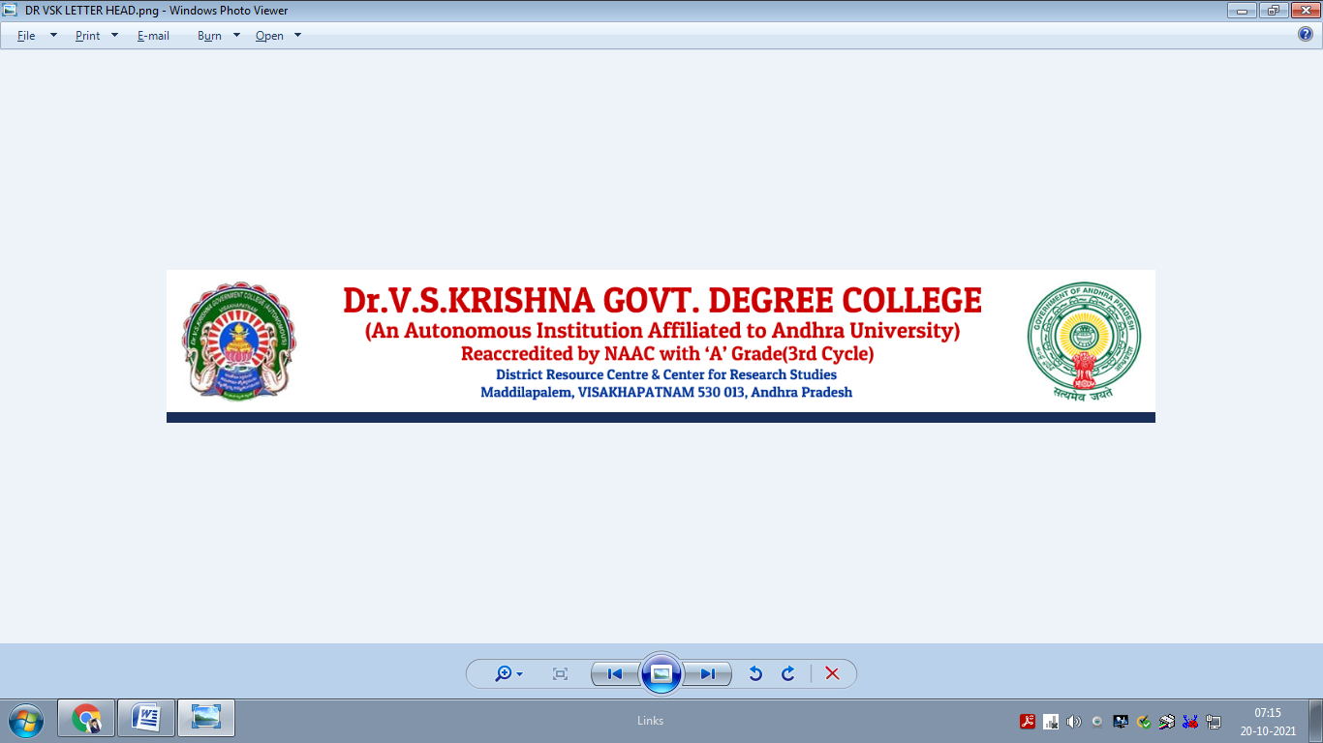

**ACHIEVEMENTS**

**DEPARTMENT PHYSICS**

**2022 - 2023**

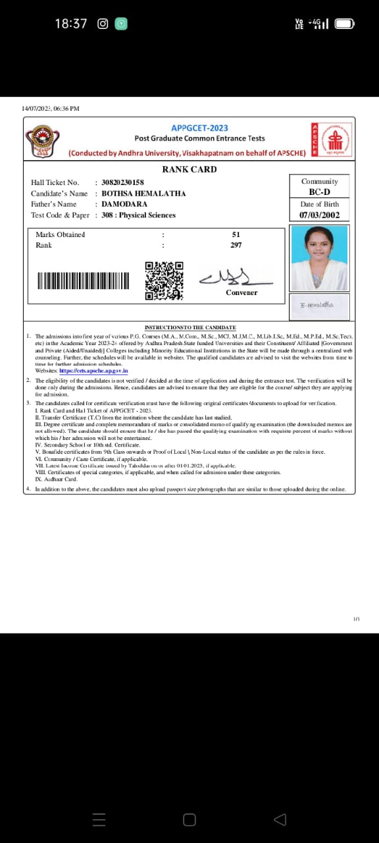**APPGCET – 2023**

Name: **Bothsa Hemalatha**

Group Studied: **B.Sc. (Physics-Honors)**

Exam: **APPGCET – 2023**

Rank: **297**

**APPGCET – 2023**

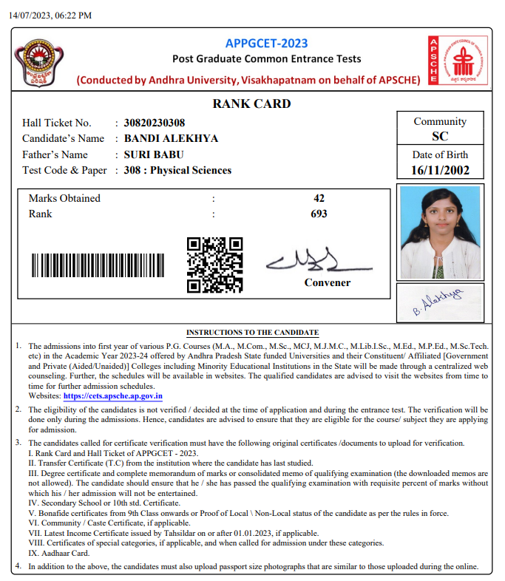

Name: **Bandi Alekhya**

Group Studied: **B.Sc. (Physics-Honors)**

Exam: **APPGCET – 2023**

Rank: **693**

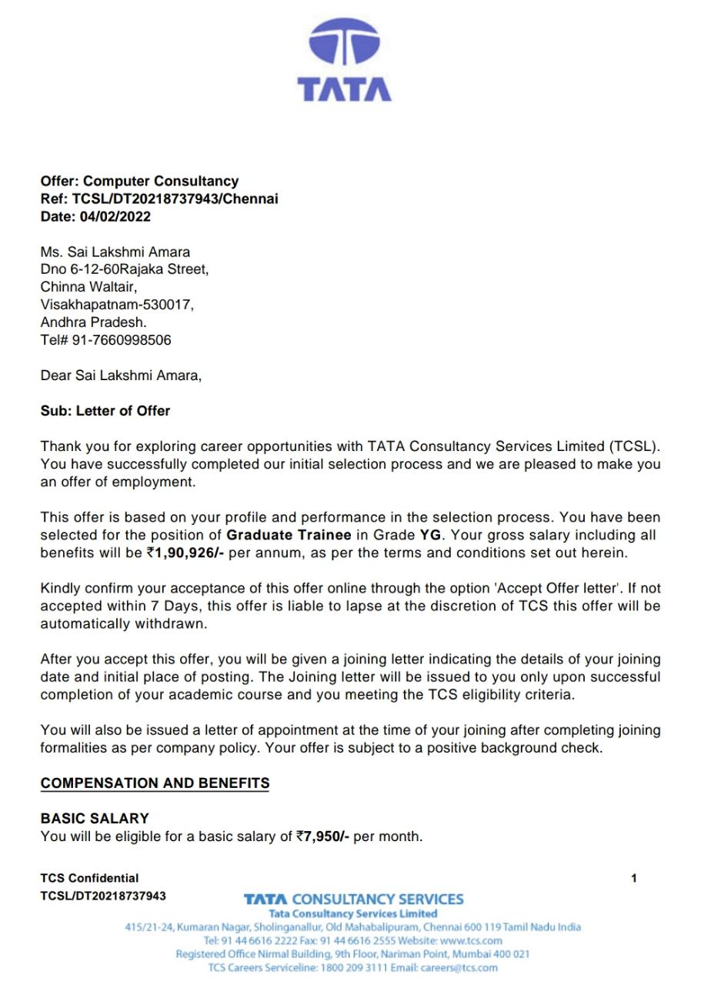**TCS NQT – 2022**

**JAM 2022 (IIT Roorkee)**

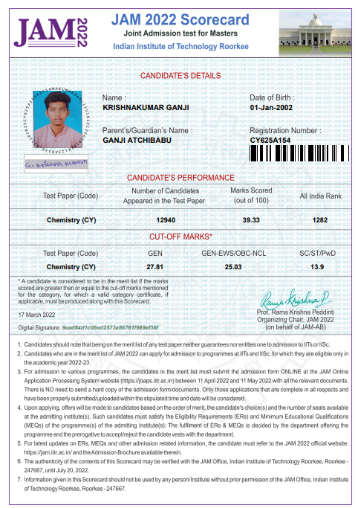

Name: **Ganji Krishnakumar**

Group Studied: **B.Sc. (MPC)**

Exam: **JAM (IIT) – 2022**

Rank: **1282**

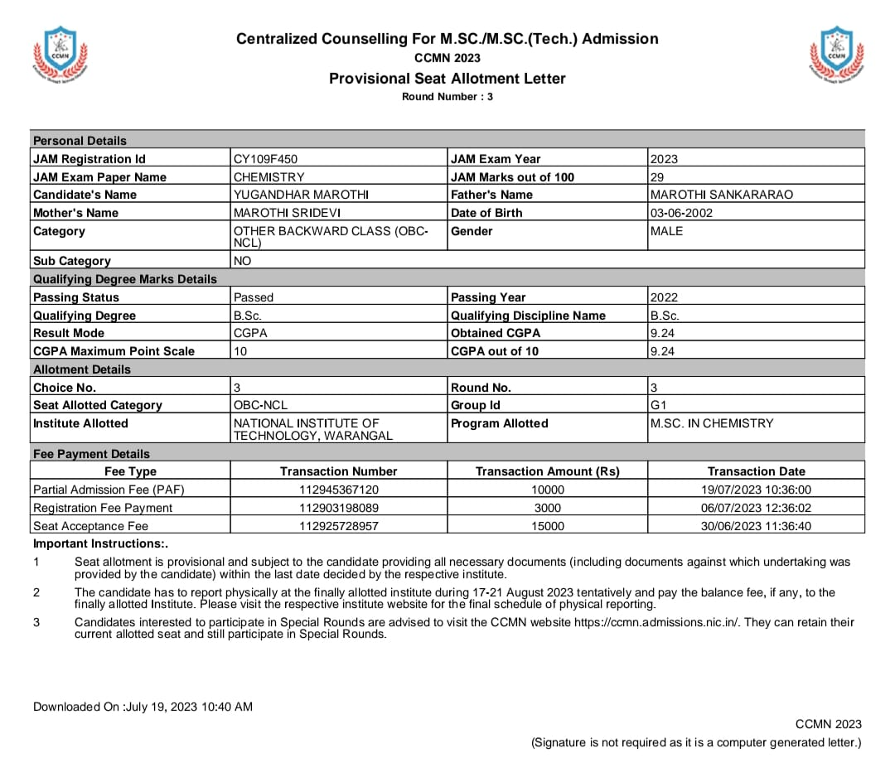**JAM 2023 (IIT Guwahati)**

Name: **Marothi Yugandhar**

Group Studied: **B.Sc. (MPC)**

Exam: **JAM (IIT) – 2023**

Rank:

Marks scored: **29 (Out of 100)**

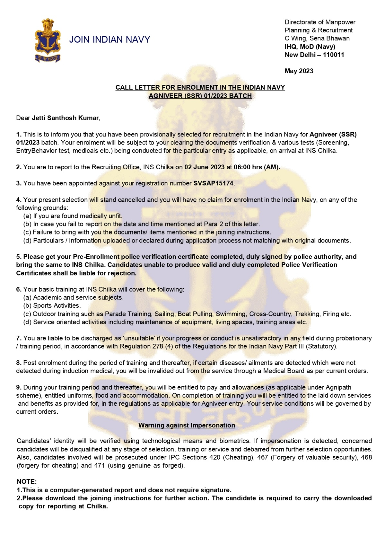**Indian Navy (Agniveer) recruitment 2023**

Name: **Jetti Santosh Kumar**

Group Studied: **B.Sc. (Physics-Honors)**

Exam: **Indian Navy**

Rank: **Agniveer (SSR)**

Marks scored: **Selected for the recruitment in the Indian Navy**